MSc Project Plan
Module Codes: COMP4031
Student Name: Ke Jung Yu
Student ID: 20780510
Course: Individual Project: Human-Computer Interaction (MSc HCI)
Supervisor: Joy Egede

Machine Learning for Characterising Caring Touch in Haptic and Robotic Systems
The aim of this project is to computationally characterise "caring touch" through a multi-stage analysis of tactile interaction data. By using instrumented infant dolls and force-sensing technology, the research seeks to uncover patterns, classify interaction types, and develop a framework that provides the information of socially intelligent robotic and haptic systems.

Project Overview
This project explores how caring touch can be computationally characterized using force sensing, machine learning, and multimodal data analysis. The methodology involves recruiting new parents as participants to interact with instrumented infant dolls equipped with force sensors, enabling the controlled collection of high-resolution tactile interaction data. Additionally, qualitative descriptive data will be gathered to help recognize and contextualize the data related to caring interactions. The research will involve designing data processing pipelines, exploring feature extraction and temporal modeling techniques, and evaluating machine learning approaches to uncover meaningful patterns in the data. The findings will provide essential knowledge for the development of intelligent haptic technologies and socially interactive robotic systems. The project will also develop innovative data analysis approaches with potential for publication.

Related Work
Previous researches have shown that caring touch plays an important role in human communication and parent–infant interaction [5]. Existing studies have explored touch perception using psychological observation and questionnaires [1], while engineering research has developed tactile sensing technologies for robotic applications. However, current robotic systems mainly focus on physical contact recognition rather than understanding the social and emotional meaning of touch [2]. Furthermore, caring touch involves complex temporal patterns, such as rhythm, duration, and force variation, which remain underexplored from a computational perspective. This project aims to address this gap by collecting tactile interaction data using instrumented infant dolls and applying machine learning approaches to characterise patterns of caring touch, contributing to future socially interactive haptic and robotic systems.

Methodology
The project will involve collecting tactile interaction data from instrumented infant dolls, followed by preprocessing and feature extraction to identify meaningful characteristics of caring touch. Machine learning approaches, including supervised classification, unsupervised clustering, and temporal modelling techniques, will be explored depending on the structure of the collected data. Python-based tools such as Scikit-learn and PyTorch will be used for analysis and model development. The developed approaches will be evaluated using appropriate metrics such as classification accuracy, F1-score, clustering quality measures, and comparison with human annotations where available.

5. Programme of Work
WP1 – Literature Review
Description:
Review existing research on:
- caring touch
- haptic sensing [4]
- human-robot interaction [3]
- machine learning for time-series data
Identify suitable ML approaches and define the research questions.
Milestone M1 – find research gap

WP2 - Data Collection and Dataset Preparation
Description:
Collect tactile interaction data using instrumented infant dolls with force sensors.
Process and organise the collected data, including:
- sensor data cleaning
- annotation
- data formatting
Milestone M2 – mark labelled samples

WP3 - Feature Extraction and Data Analysis
Description:
Analyse tactile interaction patterns and extract meaningful features.
Possible features:
- force intensity
- duration
- rhythm
- temporal changes
Explore whether caring touch patterns can be identified from sensor data.
Milestone M3 – discover initial touch pattern

WP4 - Machine Learning Model Development
Description:
Develop and compare machine learning approaches.
Depending on the data:
- classification models
- clustering methods
- sequence modelling approaches
Evaluate different approaches for characterising caring touch.
Milestone M4 – complete one machine learning model and get useful information

WP5 - Visualisation and Interpretation
Description:
Develop visualisation methods to understand interaction dynamics.
Visualise:
- touch timeline
- force changes
- model predictions
Analyse how ML outputs relate to caring touch behaviour.
Milestone M5 – result visualization

WP6 - Evaluation and Dissertation
Description:
Evaluate the developed methods using appropriate metrics.
Compare:
- different ML methods
- model performance
- agreement with human annotations (if available)
Document findings in the MSc dissertation.
Milestone M6 – evaluation and dissertation submission

6. Project Timeline
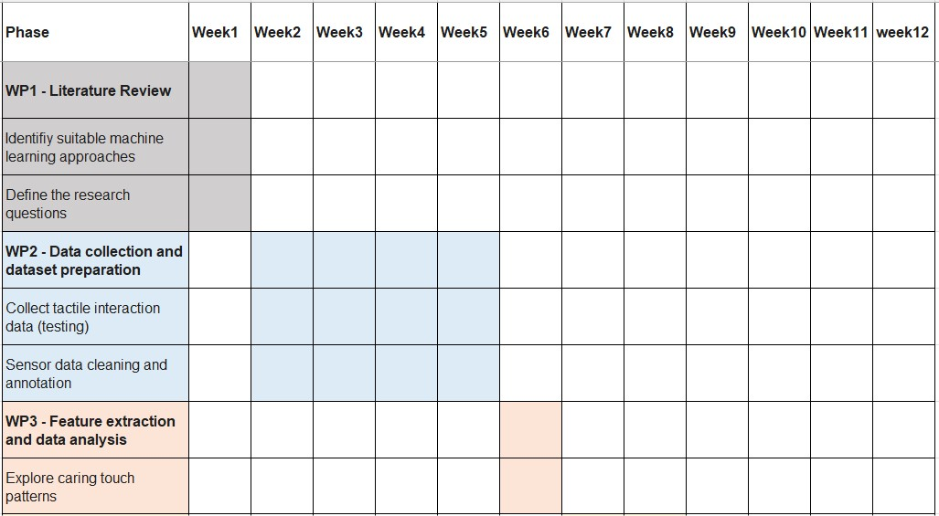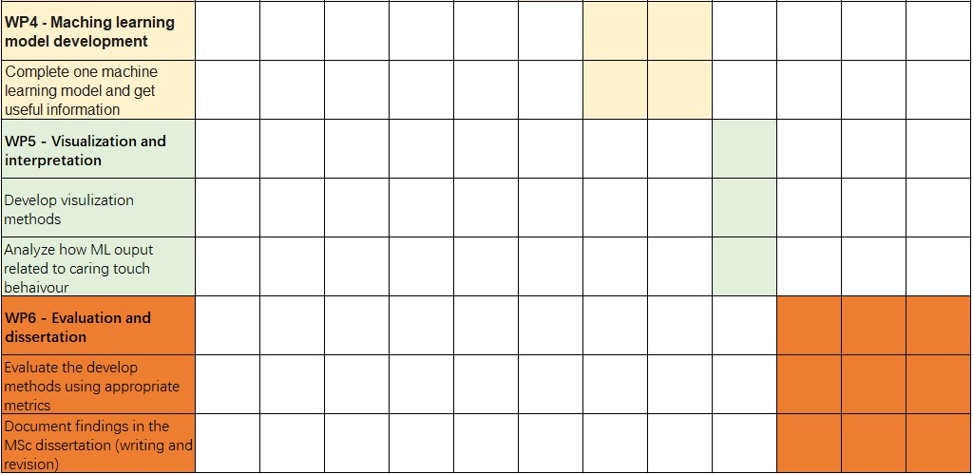

Additional Information
[1] Caroline Yan Zheng, Yuting Chen, Adrian Latupeirissa, Georgios Andrikopoulos, Anna Ståhl, and Madeline Balaam. 2025. Towards Caring Touch From Technologies: Knowledge From Healthcare Practitioners. In Proceedings of the 2025 CHI Conference on Human Factors in Computing Systems (CHI '25). Association for Computing Machinery, New York, NY, USA, Article 505, 1–16. https://doi.org/10.1145/3706598.3713736

[2] Eran Bamani Beeri, Eden Nissinman, and Avishai Sintov. 2026. DiG-Net: Enhancing Human–Robot Interaction through Hyper-Range Dynamic Gesture Recognition in Assistive Robotics. J. Hum.-Robot Interact. 15, 4, Article 72 (July 2026), 24 pages. https://doi.org/10.1145/3803864

[3] Hui-Ru Ho. 2026. Empowering Human Learning through Human-Robot Interaction. In Companion Proceedings of the 21st ACM/IEEE International Conference on Human-Robot Interaction (HRI Companion '26). Association for Computing Machinery, New York, NY, USA, 1329–1331. https://doi.org/10.1145/3776734.3794630

[4] Wataru Wakita and Hiromi T. Tanaka. 2014. An unconstrained tactile rendering with tablet device based on time-series haptic sensing with bilateral control. In ACM SIGGRAPH 2014 Posters (SIGGRAPH '14). Association for Computing Machinery, New York, NY, USA, Article 44, 1. https://doi.org/10.1145/2614217.2614272

[5] Zheng, C. Y., Latupeirissa, A., Chen, Y., Woodward, K., Balaam, M., & Andrikopoulos, G. (2026). A Wearable E-Textile Force-Sensing Garment for Characterizing Caring Touch. IEEE Sensors Journal, 26(10), 14906–14914. https://doi.org/10.1109/JSEN.2025.3640512

Word Count: 623

